**Summary of 2020 Activities (LMAG-Tokyo)**

***A. Meetings***

1. **LMAG-Tokyo Annual General Assembly**

The 2020 LMAG-Tokyo General Assembly was held on WebEx, from 14:00 to 14:30, April 3, Friday, 2020. The assembly was presided by Dr. Ohta, Secretary. At the beginning, it was reported that the participants were 25 and other 630 LMAG-Tokyo members entrusted the executive. After the officers for 2020 (Dr. Takano, Chair, Dr. Imai, Vice Chair, and Dr. Ohta, Secretary) were introduced, Prof. Takano gave an address and continued the discussion as the chair on the following agendas.

Agenda 1: Report on 2018 LMAG-Tokyo Activities

Agenda 2: Activity Plan for 2020

Agenda 3: Amendment of LMAG-Tokyo Management and Procedures

All the agendas were finally approved.

The first WebEx on-line General Assembly was successfully accomplished.

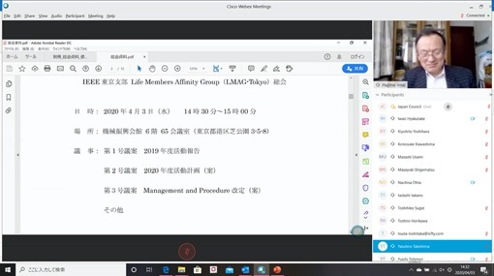

Photo. Dr. Imai, Vice Chair, reporting 2019 activities at General Assembly using WebEx.

1. **LMAG-Tokyo Officer Meetings**

We held **six** officer meetings for management on Feb. 13 (face-to-face), April 5 (Zoom), Aug. 18 (Zoom), Aug. 25 (Zoom), Oct. 6 (Face-To-Face), and Dec. 8 (Zoom). **Two** meetings were in-persona and **four** meetings were online. All officers participated in the meetings and discussed details of the operations. Another e-mail meeting was held to fix a new officer candidate on Aug. 28, 2020.

**3. Technical Meetings**

LMAG-Tokyo sponsored or co-sponsored **eight** online meetings (including 10th Anniversary event) as described below:

**(1) Lecture Meeting “CPS-driven Social Innovation for Society 5.0”**

The lecture meeting was first scheduled to be held at the General Assembly of IEEE-Tokyo and LMAG-Tokyo in April, but it was interrupted due to the COVID-19 pandemic. Finally, it was held online at 15:00-17:00 on June 5, Friday sponsored by both of IEEE Tokyo Section and LMAG Tokyo. The participants were 65 in number. This was the first remote lecture using WebEx system in IEEE Tokyo Section. The lecturer was Dr. Yoshihiro Shiroishi of HITACHI Ltd.

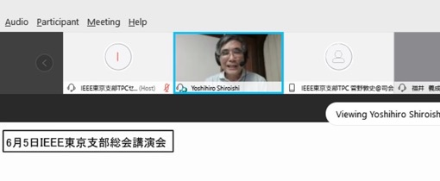

**Photo. Dr.** Shiroishi giving his talk. (captured and enlarged from WebEx screen)

**(2) Lecture Meeting “Frontier of AI and Face Recognition Technology”**

The lecture meeting was held sponsored by LMAG-Tokyo and TPC of IEEE Tokyo Section using Zoom Webinar system in a hybrid style on July 27(Mon) from 15:30 – 17:00. The lecturer was Dr. Hitoshi Imaoka, NEC Fellow, NEC Corp. Participants were 69 online and 8 at the meeting room in Kikai-Shinko-Kaikan 6F.

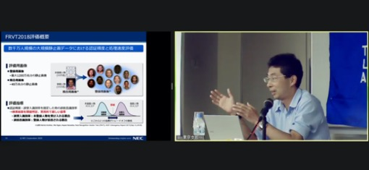

Photo. **Dr. Imaoka giving a lecture online (captured from Zoom screen).**

**(3) Lecture Meeting “Ultimate Electronics using Silicon Single-electron Devices”**

The Lecture Meeting of Tokyo Section in 2020 was hosted by Tokyo Technical Program Committee (TPC) and co-sponsored by IEEE LMAG-Tokyo from 15:00 to 17:00, Friday, August 28 with 60 participants via the Web by Zoom Webinar in order to avoid Corona Virus disaster. The lecturer, Dr. Akira Fujiwara is a Senior Special Researcher, NTT Basic Research Laboratories, and was awarded IEEE Fellow in 2018.

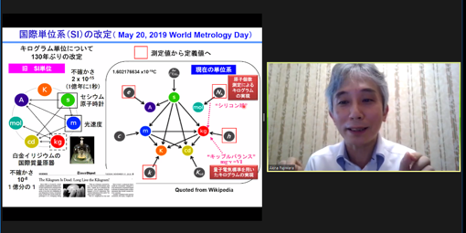

Photo. Dr. Fujiwara giving his talk (captured from Zoom screen).

**(4) Lecture Meeting “Building a Movie Map – Virtual Exploration in a City”**

The lecture meeting was held on line at 15:00-17:00 on Sept 14, Monday, sponsored by TPC of IEEE Tokyo Section and LMAG Tokyo. The lecturer was Dr. Kiyoharu Aizawa. He is a Professor at the Department of Information and Communication Engineering of the University of Tokyo, awarded an IEEE Fellow in 2016. There were 208 participants on line.

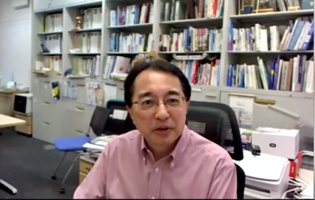

Photo. Dr. Aizawa giving his talk.

**(5) LMAG-Tokyo 10th Anniversary Symposium and IEEE Day Celebrations**

LMAG-Tokyo held 10th Anniversary Symposium and IEEE Day celebrations online at 14:00 – 17:00 on October 8, 2020 with 70 participants. The event was chaired by Dr. Imai, LMAG-Tokyo Vice-Chair, and started with sponsor’s addresses by Dr. Tokuda, Tokyo Section Chair and Dr. Takano, LMAG-Tokyo Chair. Congratulatory speeches by Dr. Fukuda, IEEE President and other important guests followed. Then, the founding chair, Dr. Habara, gave a talk entitled “Dawn of LMAG-Tokyo”. The subsequent panel discussion was moderated by Dr. Ohta, LMAG-Tokyo Secretary, and raised various suggestions to LMAG activity. After a short break, a variety of congratulatory messages were introduced. A Champagne bottle was uncorked and Dr. Takano led a toast for celebrating IEEE Day and LMAG-Tokyo’s 10th anniversary. Due to COVID19 pandemic, the event was unusual compared with conventional ones. However, thanks to the strong support of AGs and all IEEE members, this event ended with a great success.

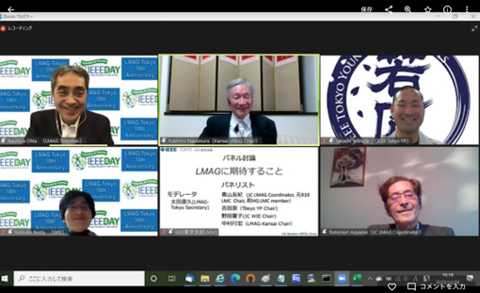

Photo. Active discussion in the panel

(from upper left: Dr. Ohta, Dr. Nakamura and Dr. Yoshida)

(from lower left Dr. Noda and Dr. Aoyama)

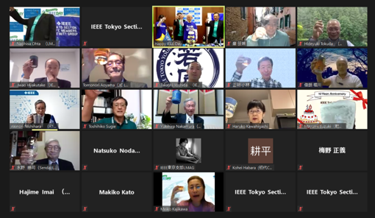

Photo. Drinking a toast online（captured from Zoom screen）

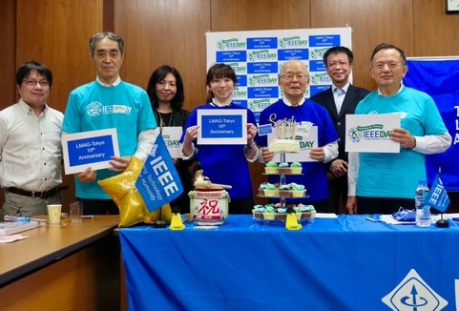

Photo. Participants in the venue (Kikai-Shinko Kaikan) (from left Dr. Kanno, Dr. Ohta, Ms. Mitsui, Ms, Kato, Dr. Takano, Dr. Takishima and Dr. Imai)

(6) Lecture Meeting “Networked Autonomy”

Online Lecture held at 15:00 – 16:30 on Nov. 16 (Mon), 2020. The lecturer was Dr. Masayuki Fujita, Professor, the University of Tokyo. Participants were 84 in number.

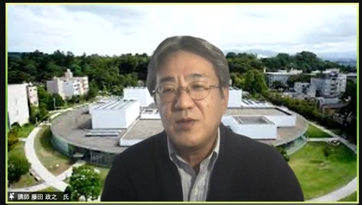

Photo. Dr. Fujita giving his lecture online (captured from Zoom screen).

(7) Lecture Meeting “Video Coding: Development, Standardization and Expansion”

This meeting was held sponsored by LMAG and TPC of IEEE Tokyo Section at 15:00 to 17:00 on 7 December in the Web form of Zoom gathering 95 participants. The speaker was Dr. Kohtaro Asai, a technical advisor of Mitsubishi Electric Company, who was awarded IEEE Fellow in 2018.

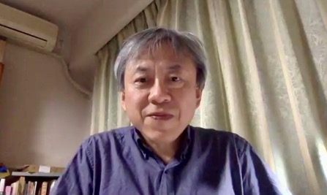

Photo. Dr. Asai giving his lecture on-line (captured from Zoom screen).

**(8) Lecture Meeting Associated with IEEE Milestone**

IEEE Milestone Award Commemorative Lectures were given online on the following topics at 14:00-16:00 on Dec. 15, 2020 after the award dedication ceremony. The participants were 223 in number.

- First Operational Large-Scale Latent Fingerprint Identification System

Speakers: Mr. Yukio Hoshino and Mr. Masanori Hara  
- First Commercial Digital Signal Processor Chip

Speakers: Dr. Takao Nishitani and Mr. Yuichi Kawakami

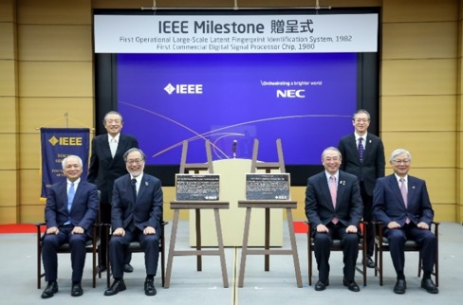

Photo. A scene of the award ceremony. In the front row, from the left: Dr. H. Tokuda, Dr. T. Fukuda, both from IEEE, and Dr. N. Endo, Mr. T. Niino, both from NEC. In the back row, from the left: Dr. I. Shirakawa, IEEE JCHC Chair and Mr. M. Nishihara, NEC Director.

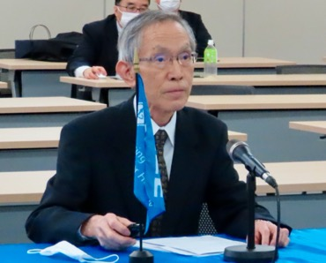

Photo. Mr. Hoshino giving his lecture.

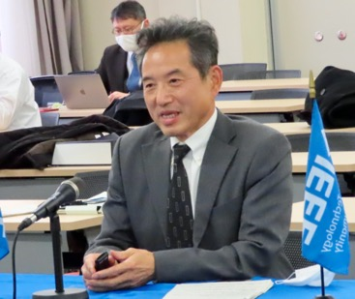

Photo. Mr. Hara giving his lecture.

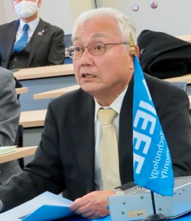

Photo. Mr. Kawakami giving his lecture.

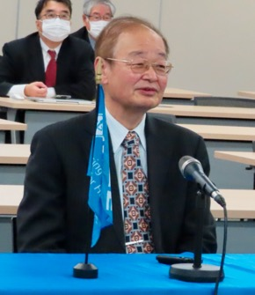

Photo. Dr. Nishitani giving his lecture.

**(9) Participated and organized sessions in 2020 R10 SYWL Congress**

The event, a region-wide congress covering 4 AGs (S: Student, Y: Young Professionals, W: Women in Engineering, and L: Life Members) in R10, was held online from Sept.19 to Oct. 4, 2020. It gathered 1553 participants altogether.

LMAG-Tokyo members participated as a moderator and speakers in two sessions of Life Member Track and as attendees in other sessions. In this article, activities in the following two sessions are reported.

1. LM Track Session1 – LMAG Meet

　This session was planned that all 16 LMAGs in R10 meet in a venue and they report and share their activities to discuss the activity goal. Actually 9 LMAG Chairs or Vice Chairs participated online and 30 people attended altogether. Mr. Asthana, R10 LMAG Committee (LMC) Chair, presented activity goals and agenda of LMC for 2020, and each LMAG’s activity was reported.

Dr. Takano, LMAG-Tokyo Chair could not attend the session due to a trouble of the conference system’s password so that Dr. Ohta, LMAG-Tokyo Secretary presented LMAG-Tokyo activity as a substitute. This session was a good opportunity for LMAGs in R10 as they could meet together online, share and discuss their activities.

1. LM Track Session 4 – IEEE Milestones

Dr. Imai, LMAG-Tokyo Vice-chair delivered a speech on IEEE Milestones, while Dr. Ohta, LMAG-Tokyo Secretary moderated the session. The number of online attendants was 33.

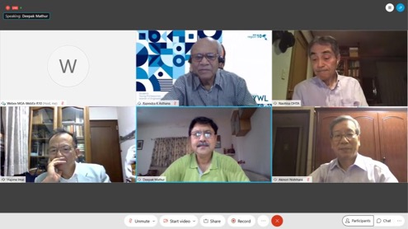

Photo. IEEE Milestones Session (from upper left: Mr. Asthana, Dr. Ohta, from lower left: Dr. Imai, Dr. Ahmad, and Dr. Nishihara)

**(10) Participated in Japan SYWL Workshop in Hiroshima (and online) 2020**

The workshop was held at 9:50 ~ 12:30 on Oct. 17 (Sat) in a hybrid manner (in-person workshop at Hiroshima Garden Palace Hotel mixed with online participation by Zoom) sponsored by the IEEE Japan SYWL workshop organizing committee and Japan Council. The event was also co-sponsored by all the Affinity Groups (AGs) in Japan, Student Branch, Young Professionals, Women in Engineering and Life Member, so that it was a valuable opportunity for the AG members to get together. The workshop theme was “MAKE A NEW NORMAL ~ we change the future by ourselves~” and attracted 43 participants (20 onsite and 23 online) including 4 LMs.

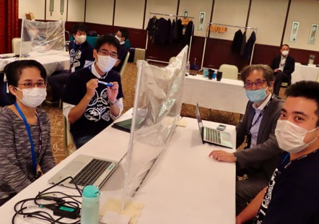

Photo. On-site participants discussing their theme.

**(11) Participated in 17th TOWERS Workshop**

TOWERS (Transdisciplinary-Oriented Workshop for Emerging Researchers) is organized for young IEEE members, and is operated by student members. This 17th workshop was held on November 27, via Web meeting due to COVID 19. The total attendants were 105. Two LMs from LMAG-Tokyo participated in the workshop and evaluated quality of poster presentations online in the virtual environment.

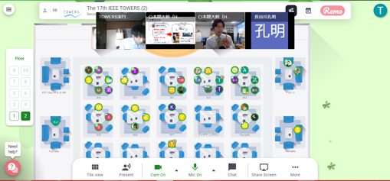

Photo. The virtual meeting room on the Web.

**(11) Participated in Lecture Meeting on Technology Information by LMAG-Nagoya**

This meeting was composed of 4 lectures and a panel discussion, and held on-line at 13:30 to 17:30 on 28 November. Members of LMAG-Tokyo attended to utilize the event opportunity and to share information.

**(12) Participated in Tokyo-Shin-etsu Joint Section WIE Kick-off Event**

The kick-off event was held online (Zoom) at 15:00 ~ 17:00 on Dec. 5 (Sat) with 34 participants including 3 LMs from LMAG-Tokyo. LMAG-Tokyo members attended to support WIE activity.

**4. LMAG Joint Officer Meeting in Japan**

The first LMAG Joint Meeting consisting of all Japanese LMAGs (Kansai, Tokyo, Nagoya and Sendai) was held on December 18 from 19:00 – 22:00 online using Zoom. This meeting was proposed by Prof. Takano, LMAG-Tokyo Chair and organized by Prof. Nakamura, LMAG-Kansai Chair. There were 20 officers and related people from each Japanese LMAG attended.

First, Prof. Aoyama, JC LM Coordinator reported discussions in the JC Board Meeting. He referred to a number of Life Members in JC (1,018), LMAG activities, and a potential for new LMAG foundation. He also encouraged LMAG-Tokyo to apply for the Achievement Award and suggested the next JC LM Coordinator. Then, all participants introduced themselves and shared some ideas and proposals for new activities of LMAGs including music and culture.

The meeting was also regarded as a get-together, and all attendants enjoyed talking about a variety of LMAG topics fully for 3 hours until closing.

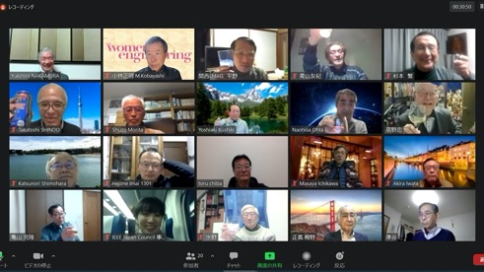

Photo. Screen shot of attendants, captured from the Zoom screen.

*B. Newsletters*

LMAG-Tokyo published three Newsletters in 2020 through e-mail announcements and on the Web site.

**No. 28 Issued on Jun. 30, 2020 https://www.ieee-jp.org/section/tokyo/lmag/newsletter/2020/28_e.pdf**

**No. 29 Issued on Oct. 30, 2020 https://www.ieee-jp.org/section/tokyo/lmag/newsletter/2020/29_e.pdf**

**No. 30 Issued on Dec. 27, 2020 https://www.ieee-jp.org/section/tokyo/lmag/newsletter/2020/30_e.pdf**

*C. Home Page*

We improved LMAG-Tokyo Web site (for better readability etc.)

https://ieee-jp.org/section/tokyo/en/about/lmag.html

*D. LOGO*

We adopted the new LMAG Logo in Newsletter and Web site.

**IEEE Tokyo Section**

**Life Member Affinity Group**

